Board Meeting Held in Public
Wednesday 26th March 2025
Title: | Learning from Deaths Quarterly Report Q3: Oct-Dec 2024
Responsible Director: | Executive Medical Director
Author: | Deputy Medical Director for Quality and Safety

Purpose of the report and summary of key issues: | The board is asked to note the surveillance of mortality indices across the trust.
BAF Risk: | AIM 1: To be an outstanding place to work
BAF Risk: | BAF1.1 to be an outstanding place to work
BAF Risk: | BAF1.2 To be an inclusive employer where diversity is celebrated and valued
BAF Risk: | AIM 2: To work with partners to deliver integrated care
BAF Risk: | BAF2.1 To improve population health and wellbeing, provide integrated care and to support primary care | X
BAF Risk: | BAF2.2 To be an active partner in population health and the transformation of health inequalities
BAF Risk: | AIM 3: To deliver high quality care
BAF Risk: | BAF3.1 and 3.4 To provide outstanding care and outstanding patient experience | X
BAF Risk: | BAF3.2 To provide a high quality service | X
BAF Risk: | BAF3.3 To provide high quality care to children and young people in adults community services
BAF Risk: | BAF3.5 To provide high quality public health 0-19 services
BAF Risk: | AIM 4: To ensure clinical and financial sustainability
BAF Risk: | BAF4.1 To continually improve services we provide to our population in a way that are more efficient
BAF Risk: | BAF4.2 and 4.3 To provide high quality care and to be a financially sustainable organisation
BAF Risk: | BAF4.4 To be financially stable to provide outstanding quality of care
Corporate Risks | N/A
Report History: | Paper also submitted to End of Life Group, Patient Safety Forum, Quality Governance Management Group and Quality Committee
Recommendation: | The board is asked to note the contents of the report, including the metrics and methodology used.

Board Meeting Held in Public

Wednesday 26^{h} March 2025

Learning from Deaths Quarter 3 Report

Executive Medical Director

- Executive Summary

Crude mortality rates for the trust continue to oscillate around national level.

SHMI has risen which is most likely a data accuracy issue due to delays in clinical coding. Observed number of death remains at a stable level.

21 cases have undergone a structured judgement review since the last report. Learning from these reports is shared within and across the organisation.

- Introduction

Although mortality represents a very small percentage of all trust activity, it is important that it is monitored and examined appropriately. This report aims to triangulate mortality indices with other markers of quality of care, in particular that provided by structured judgemental reviews (SJRs) of medical records.

- Findings

  - Crude Mortality Data
The crude mortality rate for admissions gives a long-term view of trust mortality. In total, 199 deaths were recorded in Q3, up from 175 in the preceding Q2 and also up compared to Q3 in 23/24 which had 189 deaths. A regional increase has been identified by Medical Examiners across the north of England who have estimated an approximate 20% increase in total deaths (hospital and community) compared to last winter. This data is not risk-adjusted so takes no account of the unique characteristics of individual admissions. Comparison with the national mortality rate is also shown where data is available (shown in the darker blue line in Figures 1 and 2). This demonstrates that the peaks and troughs we see in HDFT are often mirrored at the national level. Figure 2 gives a “zoomed in” view of data from the last 2 years. Note that the 12 month rolling mortality has generally declined since 2010 (apart from the impact of the Covid pandemic). It should be remembered that the denominator for this data is the number of hospital episodes, so as we increase elective work (including endoscopies), the percentage of deaths would be expected to fall.

Figure 1: Crude mortality rates over the last 14 years (%deaths per hospital episode)

Figure 2: Expanded crude mortality rates over the last 2 years (%deaths per hospital episode)

  - Standardised Hospital Mortality Index (SHMI)
Figure 3 shows our NHS England 12 month rolling SHMI compared to regional peer organisation, with Figure 4 comparing HDFT to national peers: 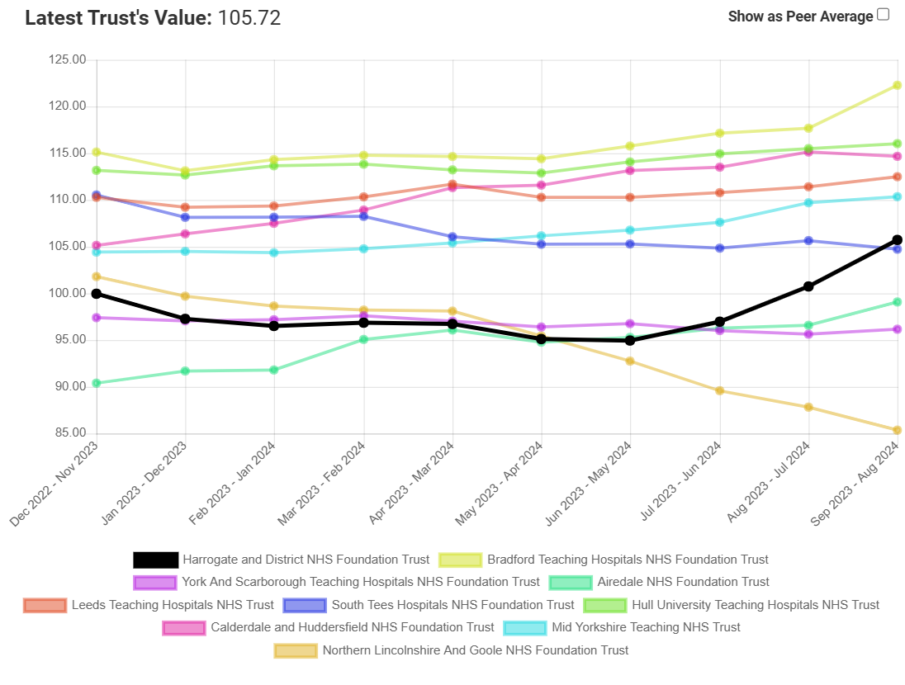
Figure 3: HDFT SHMI since December 2022 versus regional peers

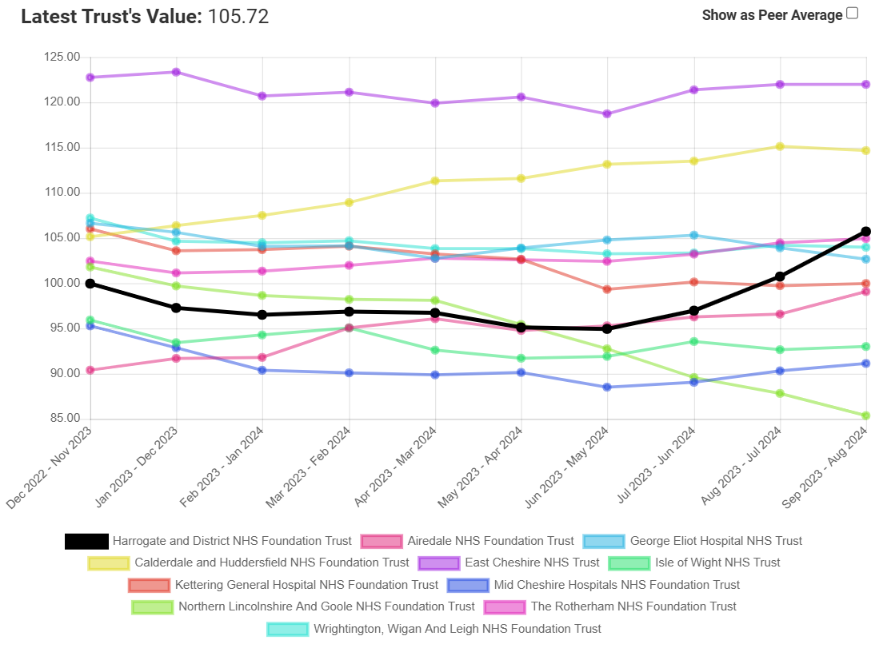 Figure 4: HDFT SHMI since December 2022 versus national peers

As can be seen, our SHMI has been rising since June 2024. Further interrogation of the data shows that the number of deaths has remained fairly constant (Figure 5), but the number of expected deaths has almost halved (Figure 6):

Figure 5: Observed number of deaths (in hospital or within 30 days of discharge)

Figure 6: Expected number of deaths (in hospital or within 30 days of discharge)

A significant fall in expected death numbers raises concerns of a data quality issue. Following interrogation of the data, we have identified a recent increase in patients’ diagnostic code in the category “Invalid primary diagnosis”. As can be shown in Figure 7, we normally have very few spells in this category, but it has sharply risen in 24/25 year to date. The reason behind the rise of this coding category is likely due to incomplete clinical coding by the time of SHMI generation. Working with the data analytics team, an action plan to improve turnaround for clinical coding has been agreed and is now underway. We understand from our external data processing provider (HED) that our SHMI data will remain as it is for 24/25 and cannot be retrospectively adjusted.

Figure 7: Number of provider spells falling into the SHMI diagnostic category of “Invalid Primary Diagnosis”
Whilst the improvement work around timeliness of our clinical coding is underway, in the interim period, our other mortality metrics such as the observed number of deaths, any Medical Examiner concerns and the Structured Judgemental Reviews (SJRs) will continue to provide further assurance of our mortality data.

  - Structured judgement reviews (SJR)

21 cases have been reviewed in this quarter with 18 relating to deaths in this period and 3 from the preceding Q2.

We received 1 “red alert” for a diagnostic category with possible excess mortality in this quarter – deaths categorised as being due to “acute cerebrovascular disease”. This related to the cumulative number of deaths up to and including August 2024. By September, this had fallen to an “amber alert”. In the next quarter, the cases from this category with the lowest predicted mortality during the red alert period will be chosen for an SJR. This is a diagnostic area which has previously between explored with no concerns identified. We are currently finalising “business rules” as to when such intermittent alerts would trigger a more in-depth exploration of clinical cases.

In addition to cases chosen at random to provide assurance, some clinical teams select cases that they have already identified as having possible lapses in care and this therefore generates a higher number of episodes of poor care than previously (where a higher proportion of cases for review were selected at random). We are looking to add an extra field to our SJR tool so we can identify why the case was chosen for review and get a clearer picture of the incidence of each quality-of-care category.

2 cases were in patients with a learning disability who will receive a second external review as part of the LeDeR process. Feedback on their findings will be provided in subsequent papers when the reports are received.

All cases in this quarter were reviewed using the Datix iCloud SJR module which uses the most up-to-date national question set. Questions include a subjective assessment of the avoidability of death – if this were deemed to be higher than 50:50 then the process to commence a Patient Safety Incident Investigation (PSII) would be triggered. We also record if there were gaps in clinical care, organisational aspects or both. In this quarter, organisational aspects noted continued to be delays in admissions from the Emergency Department and failure to be reviewed by a consultant within 14 hours of admission.

The overall assessment of the standard of care of is shown in Table 1:

Date of admission | Care in First 24 hours | Ongoing Care | Avoidability of Death | Clinical/ Organisation score (NCEPOD) | Overall Care
04/10/2024 | Good care | Good care | Definitely not avoidable | Good practice | Good care
04/10/2024 | Adequate care | Not Applicable | Definitely not avoidable | Room for improvement in clinical care | Good care
01/10/2024 | Poor care | Poor care | Slight evidence of avoidability | Room for improvement in clinical and organisational care | Poor care
11/10/2024 | Good care | Good care | Definitely not avoidable | Good practice | Good care
27/09/2024 | Adequate care | Not Applicable | Slight evidence of avoidability | Room for improvement in clinical care | Adequate care
15/10/2024 | Excellent care | Excellent care | Definitely not avoidable | Good practice | Excellent care
07/10/2024 | Good care | Poor care | Slight evidence of avoidability | Room for improvement in clinical care | Poor care
25/11/2024 | Adequate care | Good care | Definitely not avoidable | Room for improvement in clinical care | Good care
24/10/2024 | Adequate care | Not Applicable | Definitely not avoidable | Room for improvement in organisational care | Adequate care
31/10/2024 | Good care | Not Applicable | Definitely not avoidable | Good practice | Excellent care
10/10/2024 | Adequate care | Not Applicable | Definitely not avoidable | Room for improvement in clinical and organisational care | Good care
14/11/2024 | Good care | Good care | Definitely not avoidable | Room for improvement in organisational care | Good care
12/06/2024 | Adequate care | Adequate care | Slight evidence of avoidability | Room for improvement in organisational care | Adequate care
19/11/2024 | Good care | Good care | Definitely not avoidable | Good practice | Good care
31/10/2024 | Good care | Good care | Definitely not avoidable | Good practice | Good care
29/11/2024 | Good care | Good care | Definitely not avoidable | Good practice | Good care
26/11/2024 | Good care | Good care | Definitely not avoidable | Room for improvement in organisational care | Good care
30/11/2024 | Good care | Good care | Definitely not avoidable | Good practice | Good care
18/09/2024 | Poor care | Excellent care | Slight evidence of avoidability | Good practice | Good care
03/09/2024 | Excellent care | Good care | Definitely not avoidable | Good practice | Good care
30/11/2024 | Poor care | Poor care | Slight evidence of avoidability | Room for improvement in clinical and organisational care | Poor care
Table 1: Cored details of the cases reviewed this quarter

Three cases had overall care described as “poor”. All have been highlighted for a second review by a different clinician. In all cases where poor care has been identified, the treating team will review the case in the Morbidity & Mortality review section of their regular governance meetings, with learning shared with the required colleagues.

Figure 8 below shows the breakdown of overall care this financial year:

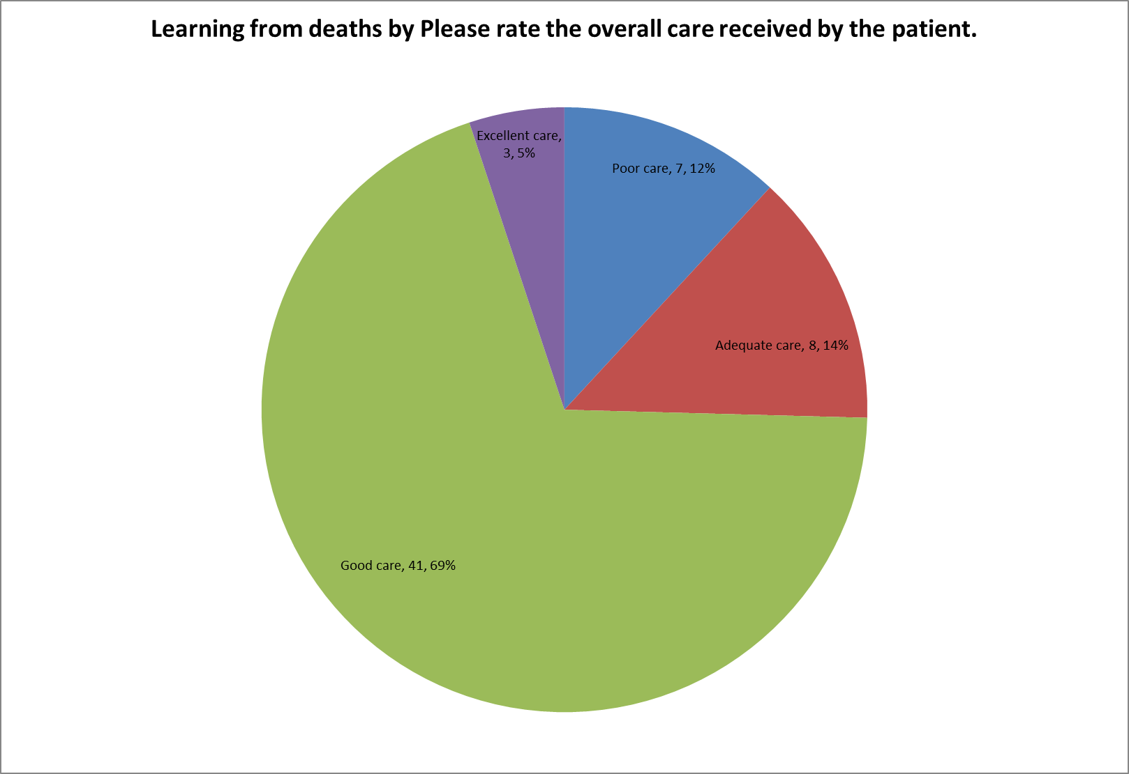

Figure 8: Overall care in all cases reviewed this financial year

Tables 2 and 3 show the quality of end-of-life care and record keeping respectively:

End of Life Care
 | 24/25 Q1 | 24/25 Q2 | 24/25 Q3
Good care | 12 | 11 | 11
Adequate care | 4 | 2 | 1
Not Applicable | 2 | 3 | 6
Poor care | 1 | 1 | 0
Excellent care | 0 | 2 | 3

Tables 2: End of Life Care provided

Patient Record Quality
 | 24/25 Q1 | 24/25 Q2 | 24/25 Q3
Good | 14 | 12 | 18
Adequate | 5 | 6 | 2
Excellent | 0 | 1 | 1

Tables 3: Quality of Patient Records

Another new section of the Datix SJR is the ability for the review to identify any positive or negative learning points from the cases. These are shared with the clinicians via the regular Medical Directorate newsletter. Positive themes this quarter related to wider use of the whole multi-disciplinary team to enhance care, the impact of advanced care planning and the contribution from the Palliative Care Team even when a patient is not in the last days of life. Negative themes include ensuring documentation of clinical encounters is thorough and ensuring sepsis care is optimised. The latter is being addresses by the Deteriorating Patient Group.

The Medical Examiner team have not identified any emerging concerns in the last quarter.

- Recommendation

The Board is asked to note the contents of this report and the processes for ensuring learning from deaths.

