


Patient and Carer Information

RIGHT HEMICOLECTOMY FOR COLON CANCER

Please read this leaflet carefully. It is important that you take note of any instructions or advice given. If you have any questions or problems that are not answered by the information here, please ask your doctor or nurse.

INTRODUCTION

Your Consultant has explained to you that you have a cancer or growth in the bowel. This needs an operation to remove it.

This leaflet helps to explain the type of operation you are going to have. This leaflet will also tell you:
- Why you are having the operation
- The risks associated with the operation
- Your recovery
- Your future care

If you have any questions or queries after reading this leaflet, the colorectal specialist nurse will be happy to go over these with you. Please refer to the back of this leaflet for contact details.

How is cancer of the colon treated?
The usual treatment for bowel cancer is surgery. This involves a major operation to remove the cancer.

What other treatments are there?
The usual treatment is surgery but sometimes cancers can be treated with chemotherapy treatment.

What is chemotherapy treatment?
Chemotherapy is a form of drug treatment and can be given intravenously and orally in the form of a tablet. The Oncologist will discuss with you the most appropriate treatment for you.

What type of operation will I have?

The operation is called a Right Hemicolectomy.
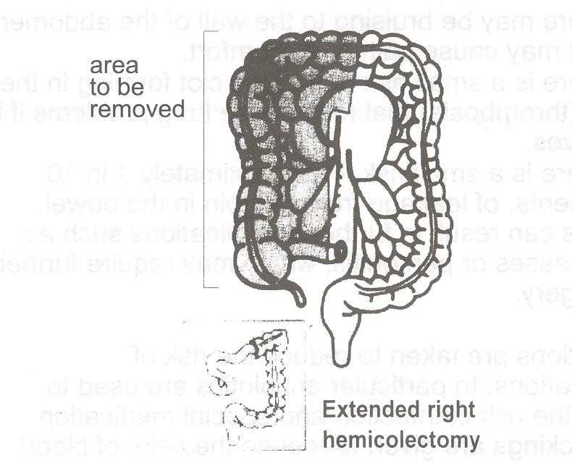

The operation involves making an incision or cut in your abdomen, and removing the right side of the colon containing the cancer. Surgery can be done laparoscopic ‘key hole’; the surgical technique will be discussed with you by your consultant. The remaining bowel will be re-joined together.

You will not need a stoma (bag) with this type of operation.

What are the risks of having an operation?
Bowel surgery is a major operation:

- Chest infection. This affects about 1 patient in 15.

- Wound infection

- Bruising to the wall of the abdomen which may cause pain or discomfort.
- Blood clot forming in the leg (DVT = Deep Vein thrombosis).
- Leak in the join of the bowel. This affects 1 in 10 patients and may require further surgery.

Precautions are taken to reduce the risk of complications. In particular, antibiotics are used to reduce the risk of infection and special medication and stockings are given to reduce the risks of blood clots.

What are the benefits of having the operation?
Surgery is the most effective way of treating bowel cancer.

If, untreated, the cancer will continue to grow and eventually, the cancer will spread and become life threatening.

How long will I be in hospital?
Your length of stay in hospital is usually 5-7 days but this does depend on how well you recover from the operation. You will have received further information on this with your enhanced recovery patient information

How long will it take to fully recover from the operation?
This is major surgery. It can take at least 6 – 8 weeks for the muscles and tissues to fully heal. We advise you to avoid any activity that may put a strain on your abdomen as this may cause problems and delay healing.

- Most people tend to be off work between 6 – 12 weeks, maybe even longer depending on their type of work.

- Usually you can drive again about a month after surgery.

What will happen after the operation?
The colon removed during surgery will be sent to the laboratory to be examined. The results will be sent back to your consultant. The results will confirm whether the tumour was a cancer and if you need further treatment.

When will I know the results?
The results will be available 10-14 days after your operation. You may be told the results whilst you are in hospital. If this is not possible, we will give you an outpatient appointment to see your consultant who will discuss your results with you.

What if the results suggest I need further treatment?
An appointment will be made for you to see the cancer (oncology) specialist consultant. He or she will discuss with the treatment options available and what is most appropriate for your cancer.

What if I do not need further treatment?
If the results indicate you do not need further treatment, then we will receive an outpatient appointment to see your consultant. The Consultant will arrange to see you regularly in the surgical outpatient clinics over the next few years to ensure you stay healthy and well.

To answer your questions and give information please contact:

Colorectal Clinical Nurse Specialist Team

Lindsay Conner (Team Lead)
Bethany Milner (CNS)
Lucy Woodward (CNS)
Caroline Bolton (Cancer Care Coordinator)

Monday to Friday
8.30 am – 4.30 pm
Tel: 01423 553340
Some useful contact numbers for further information and advice on rectal and bowel cancer:

The Sir Robert Ogden Macmillan Centre

Provides Patient Information, Health and Wellbeing and Financial Benefit support services Tel: 01423 55 7317

Macmillan Cancer Support
Provides Free Information and Support to patients and carers affected by all aspects of a cancer diagnosis.
Tel: 0808 808 00 00

Colon Cancer Concern
Free fact sheets covering diet, diagnosis, terminology and treatment. Tel: 0207 381 4711

Digestive Disorders Foundation
Provide information leaflets on all bowel disease including cancer. Tel: 0207 486 0341

If you require this information in an alternative language or format (such as Braille, audiotape or large print), please ask the staff who are looking after you.

