


Patient and Carer Information

LEFT HEMICOLECTOMY & SIGMOID COLECTOMY FOR BOWEL CANCER

Please read this leaflet carefully. It is important that you take note of any instructions or advice given. If you have any questions or problems that are not answered by the information here, please ask your doctor or nurse.

INTRODUCTION

Your Consultant has explained to you that you have a cancer in the bowel. This needs an operation to remove it.

This leaflet helps to explain the type of operation you are going to have:

- Why you are having the operation
- Risks associated with the operation
- Recovery from the operation
- Future care.

If you have any questions or queries after reading this leaflet, the Colorectal nurse specialist will be happy to go over these details with you. Please refer to the back page of this leaflet for contact information.

What is a cancer?
A cancer is a growth of abnormal cells in an area of the body. In your case, this growth of abnormal cells has occurred in the large bowel (colon).

If the cancer is not removed, it can cause local problems within the bowel and surrounding area. Eventually, it can spread to the rest of the body and become life threatening.

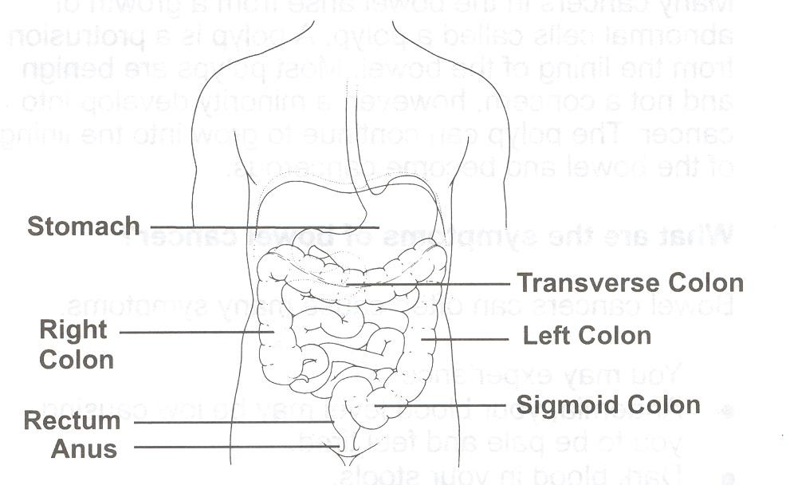
Where is the Bowel?
The large bowel is made up of the colon and the rectum.

The colon can be divided into:

  - the right colon;
  - the transverse colon;
  - the left colon;
  - the sigmoid colon.
Your cancer has been found in the left colon, or sigmoid colon. The exact site will be discussed with you by your surgeon.

You have undergone scans which have assisted the doctors in their diagnosis and helped in staging the disease. Staging allows the doctor to discuss the most appropriate treatment for you.

How is cancer of the colon treated?
Treatment for bowel cancer is surgery. This involves a major operation.

What type of operation will I have?
The operation is called a Left Hemi-colectomy or Sigmoid Colectomy, depending on the site of the cancer; this will be discussed with you.
The operation involves making an incision or cut into your abdomen. The incision will be laparoscopic ‘key hole’ or open, the surgical technique will be discussed with you by your surgeon. The left side of the colon containing the cancer will be removed and the bowel joined together.
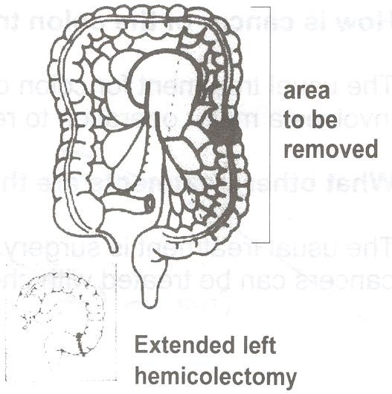

There is the possibility that you may need to have a temporary or permanent stoma (bag) with this type of operation. A stoma is when part of the bowel is brought to the surface of the abdomen and is covered with an appliance (a bag). Your bowel motions (faeces) empty into the appliance.

The stoma care nurse will see you prior to your operation and explain things in more detail and you will be given additional information to aid your understanding.
Following discharge home, the stoma nurse will visit you at home, to ensure that you are managing, and give any additional help and support you may need.

How long will I have a temporary stoma?
Approximately 4 – 6 weeks after the operation, an x-ray test called a water-soluble enema will be arranged. This is to check that the bowel has healed and there are no leakages or blockages in the re-joined area. Your consultant will then arrange to reverse the stoma.

Occasionally the x-ray test shows a leak in the bowel. This is nothing to worry about, as healing can take a little longer. The x-ray test will be repeated at a later date.
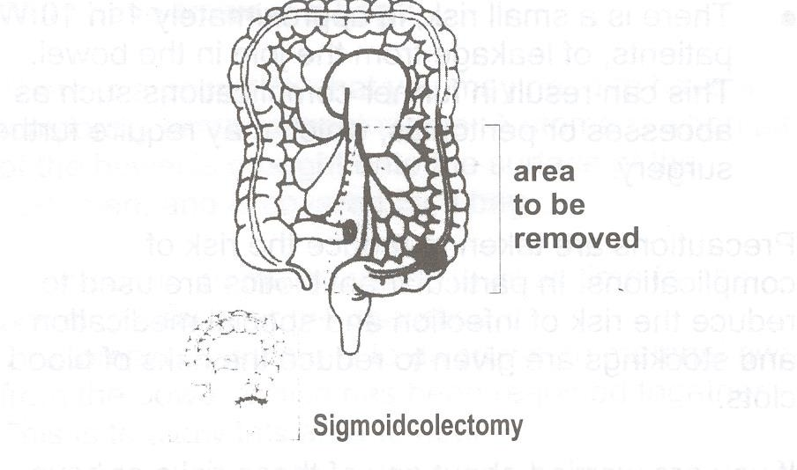

What are the risks of having an operation?

  - Chest infection. This affects about 1 patient in 15 (can be reduced by stopping smoking).
  - Wound infection affects 1:10
  - Bruising to the wall of the abdomen may cause pain or discomfort.
  - Blood clot forming in the leg (DVT= Deep Vein Thrombosis)
  - Leak in the join of the bowel this can affect 1: 20 patients. This can result in further complications such as abscesses or peritonitis, which may require further surgery.

Precautions are taken to reduce the risk of complications. In particular antibiotics are used to reduce the risk of infection and special medication and stockings are given to reduce the risks of blood clots.
If you are worried about any of these risks or have concerns regarding your operation, please speak with your doctor, ward staff or specialist nurse at the hospital.

How long will I be in hospital?
Your length of stay in hospital is usually 7 – 14 days but this can be less. You will have received an information leaflet on the enhanced recovery and this gives you more detail of your expected recovery.

How long will it take to fully recover from the operation?
It can take at least 6 – 8 weeks for the muscles and tissues to fully heal. We advise you to avoid any activity that may put a strain on your abdomen as this may cause problems and delay healing. It can take 8 – 12 weeks or more before you feel fit again. This is normal following surgery.

  - If you have a stoma, the stoma nurse will arrange to visit you at home
  - Most people tend to be off work between 6 – 12 weeks, maybe even longer depending on their type of work.
  - Usually you can drive again about a month after surgery.
As your energy levels and stamina improve, you will gradually be able to resume many of your normal activities.

If you require any further advice or information please contact:

Colorectal Clinical Nurse Specialist Team

Lindsay Conner (Team Lead), Bethany Milner (CNS), Lucy Woodward (CNS)
Caroline Bolton (Cancer Care Coordinator)

Monday to Friday - 8.30am – 4.30pm Tel: (01423) 553340

Some other useful contact numbers for further information and advice on rectal and bowel cancer:
Macmillan Cancer Support
Provides Free Information and Support to patients and carers affected by all aspects of a cancer diagnosis.
Tel: 0808 808 00 00

Colon Cancer Concern
Free fact sheets covering diet, diagnosis, terminology and treatment. Tel: 0207 381 4711

Digestive Disorders Foundation
Provides information leaflets on all bowel disease including cancer. Tel: 0207 486 0341

The Sir Robert Ogden Macmillan Centre
Provides Patient Information, Health and Wellbeing and Financial Benefit support services Tel: 01423 55 7317
If you require this information in an alternative language or format (such as Braille, audiotape or large print), please ask the staff who are looking after you.

