


Patient and Carer Information

ANTERIOR RESECTION FOR RECTAL CANCER

Please read this leaflet carefully. It is important that you take note of any instructions or advice given. If you have any questions or problems that are not answered by the information here, please ask your doctor or nurse.

INTRODUCTION

Your consultant has explained to you that you have a cancer or growth in your rectum. This needs an operation to remove it.

This leaflet helps to explain the type of operation you are going to have;

- Why you are having the operation.
- Risks associated with the operation.
- Recovery from the operation.
- Future care.
If you have any questions or queries after reading this leaflet, the colorectal nurse specialist will be happy to go over these with you. Please refer to the back of this booklet for contact details.

What is cancer?
A cancer is a growth of abnormal cells in an area of the body. In your case, this growth of abnormal cells has occurred in the rectum.

If this cancer is not removed, it can cause local problems within the rectum or surrounding area. Eventually, it can spread to the rest of the body and become life threatening.

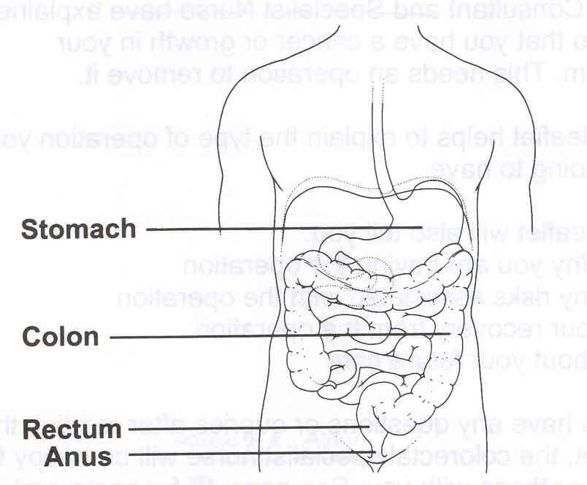
What is the rectum?
The rectum is the last 15cms of the lower end of the bowel which goes down to your anus (back passage).

The rectum stores solid waste until it is ready to leave the body through the anus. Around the anus is a ring of muscle called the anal sphincter. This sphincter opens and closes and helps to control the flow of waste from the rectum.

How is rectal cancer treated?
The usual treatment for rectal cancer is surgery. This involves a major operation to remove the tumour.

What other treatments are there?
Treatment is surgery but sometimes rectal cancers can also be treated with radiotherapy, chemotherapy or both. This can be done before or after surgery.

What is chemotherapy?
Chemotherapy is drug treatment. It can be given intravenously (into the vein), or orally in the form of a tablet.

What is radiotherapy?
Radiotherapy is X-ray treatment and is given at St James’s Hospital in Leeds. Radiotherapy can be given on its own or with chemotherapy. The appropriate treatment will be discussed with you by your surgeon.

What type of operation will I have?
The operation is called Anterior Resection.

The operation involves making an incision or cut in your abdomen and removing the section of the rectum that contains the tumour. The surgical technique will be discussed with you by your surgeon, surgery will be done either laparoscopically ‘key hole’ or open.
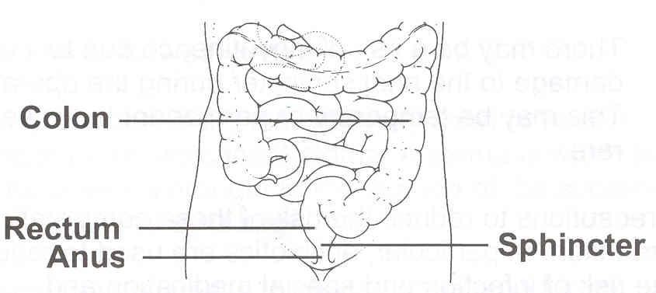
Where possible, the remaining bowel is re-joined.

If the surgeon is not happy with the “join” (anastomosis) then a temporary colostomy/ileostomy will be formed. A stoma is when part of the bowel is brought to the surface of the abdomen and covered by an appliance (a bag). The stoma care sister will discuss this with you prior to surgery.

What are the risks of having an operation?

- Chest infection. This affects about 1 patient in 15.
- Wound infection this can affect 1:10 patients
- There may be bruising to the wall of the abdomen that may cause pain or discomfort.
- Blood clot forming in the leg (Deep Vein Thrombosis =DVT)
- Leak at the join in the bowel this can affect 1 in 10 patients. This can result in further complications such as abscesses or peritonitis, which may require further surgery.

- In men there is a 10 to 15% risk of impotence due to damage that may occur to the nerves during the operation.

- Vaginal stenosis (narrowing) if radiotherapy treatment has been given prior to surgery
- Risk of faecal incontinence due to damage to the anal sphincter during the operation. This may be temporary or permanent but is rare.
- Occasionally, you may experience the sensation of wanting to open your bowels normally despite having a stoma. This is because the lower part of your bowel is healthy and is still functioning normally. You may find that you pass mucus or slime from your back passage. This is normal as the lining of the bowel produces mucus constantly.
- If you do not have a stoma you can experience altered bowel function and this will be discussed in detail with you in follow up by the team
- Depending on the extent of surgery, men may have changes in their sexual function due to the risk of damage to the nerves.
- Other cancer treatments such as chemotherapy and radiotherapy to the rectum may also cause changes in sexual function.
Cancer treatments can affect your body image and the way you see yourself sexually. Because of these feelings and symptoms, your desire for sexual intercourse may be very low. It is normal to feel like this. If you have any concerns or questions, feel free to talk to the specialist nurses or your doctor about them.

How long will I have my temporary stoma?
The temporary stoma is to divert waste material away from the bowel which has been re-joined. It allows this area time to heal.

Approximately 4 to 6 weeks after your operation, a test called a water-soluble enema will be arranged. This is to check that the bowel has healed and that there are no leaks in the joined bowel. Occasionally, the test shows a leak in the bowel. This is nothing to worry about it means that healing is taking a little longer. The test will be repeated at a later date.

How long will I be in hospital?
Your length of stay in hospital will be between 7-14 days. You will have received information on the enhanced recovery; this gives more detail on expected recovery.

How long will it take to fully recover from the operation?
It can take at least 6 weeks for the muscles and tissues to fully heal. We advise you to avoid any activity that may put a strain on your abdomen as this may cause problems and delay healing.

It can take between 6 -12 weeks or more before you feel fit again. This is normal.

- If you have a stoma, the stoma nurse will arrange to visit you at home.
- Most people tend to be off work between 6 -12 weeks, maybe even longer.
- Usually you can drive again about a month after surgery.
As your energy levels and stamina improve, you will gradually be able to resume many of your normal activities.

To answer your questions and give information please contact:

Colorectal Clinical Nurse Specialist Team

Lindsay Conner (Team Lead)
Bethany Milner (CNS)
Lucy Woodward (CNS)
Caroline Bolton (Cancer Care Coordinator)

Monday to Friday
8.30 am – 4.30 pm
Tel: 01423 553340

If you require this information in an alternative language or format (such as Braille, audiotape or large print), please ask the staff who are looking after you.

