
Specialist Children’s Services
Occupational Therapy Team
Information About Your Appointment

Your appointment will take place at one of these buildings:


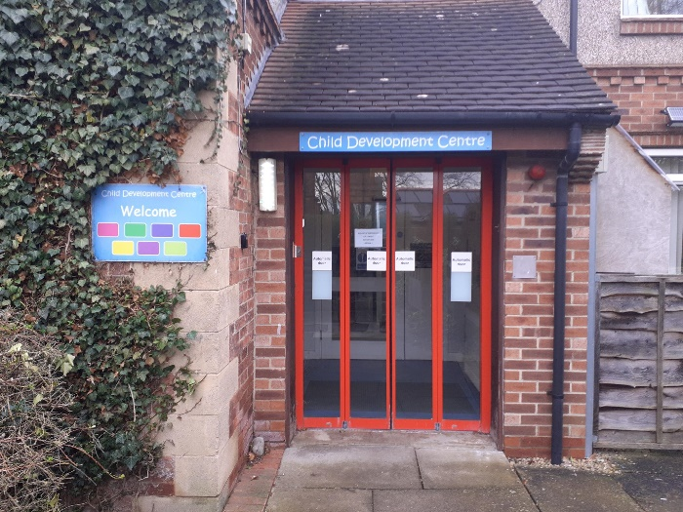

Harrogate District Hospital
Child Development Centre, Northallerton

You will be asked to wait in one of these waiting rooms:

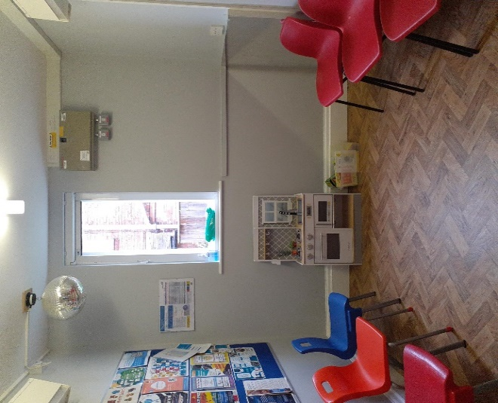
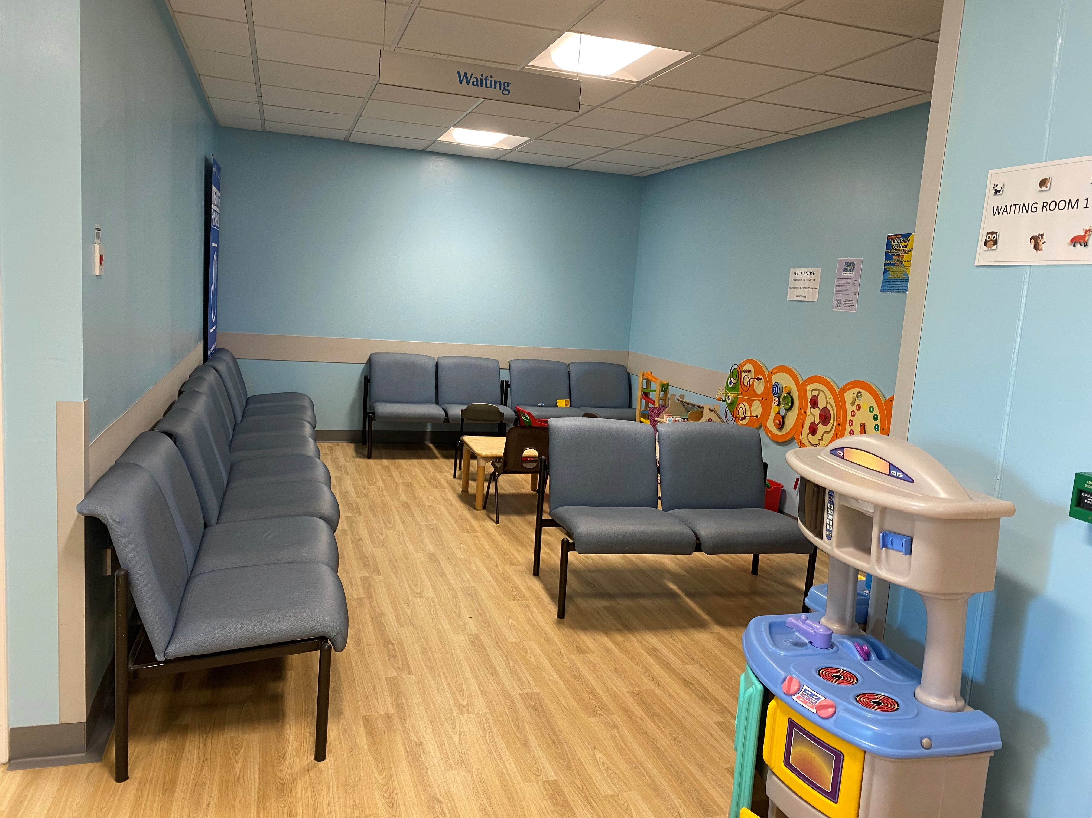

Harrogate District Hospital
Child Development Centre, Northallerton
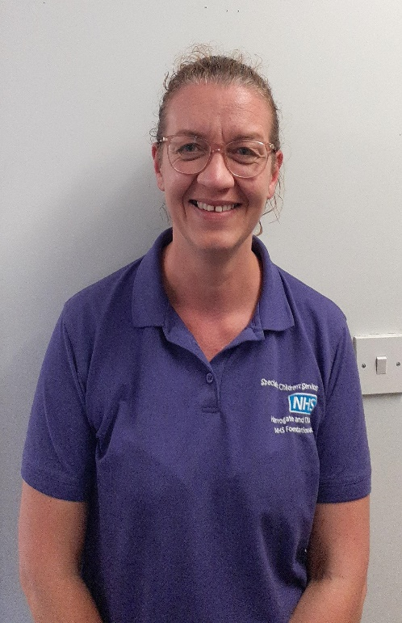
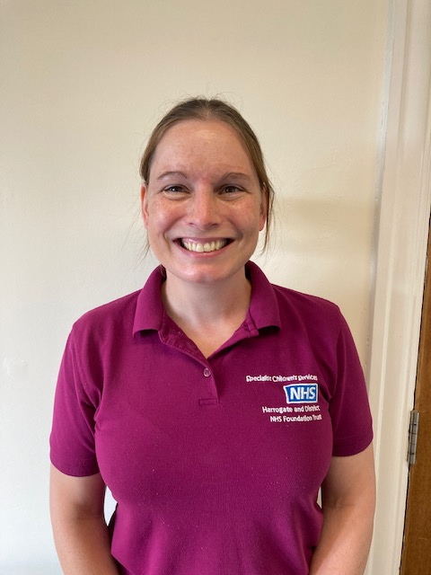
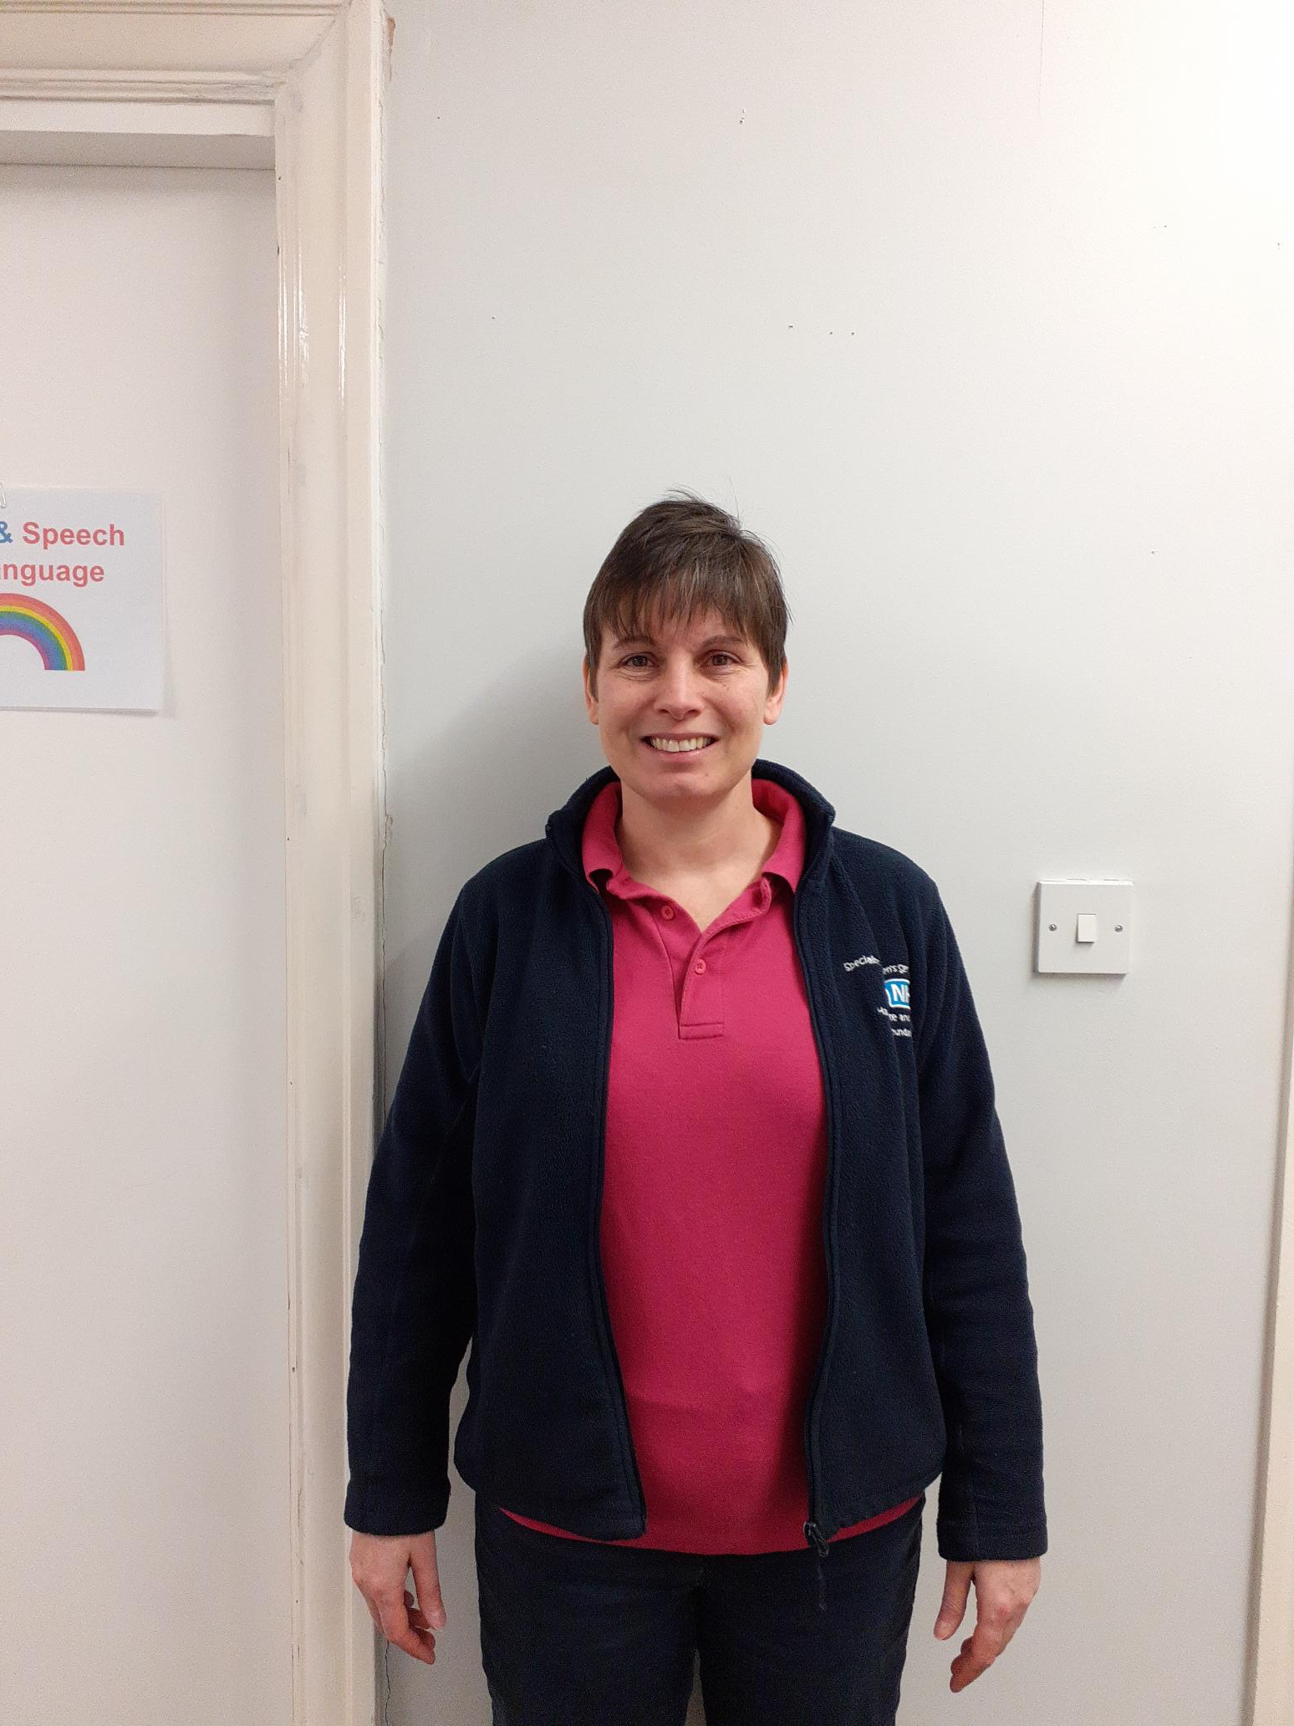
We will then come to meet you. This is our uniform:

Your parent/carer can join you in the appointment or wait for you in the waiting area.

During the assessment, we will do some practical activities. Here are some you may or may not see:

During your assessment, we will also talk to you about different parts of your life to help us get to know you.
We will ask you about:
- What you are good at and what you find difficult.
- Any worries you have.
- How you get on at home, at school and in other situations.

Information About what happens Next:

We may arrange a separate telephone appointment when we will talk to your parents/carers.

We may also need information from your teacher at school or to observe you at school.

We will also consider:

- Any physical or mental health problems you might have
- Anything else that may be making things harder for you, or affected how you have grown and developed.

All of the information we gather about you will help us work out how best to help you, and plan what support or adaptations you and your family need.

We will send you a written report explaining what we found out.

We are looking forward to meeting you and getting to know you!

Additional Information


What happens with your information?
We take our duty to protect your personal information very seriously and are committed to taking all reasonable measures to ensure the confidentiality and security of your personal data. This includes both computerised and paper records.


How we share information:
The main ways we share information is by sending written information by post or email and through using electronic patient records.

Written information:
The information we send by post or email may include letters to say that a referral has been accepted or not, questionnaires to gather information, reports on the outcome of the assessment/ work.
We routinely share information with the following people:
- You (the patient) or- the parent(s)/carer(s)
- Your GP
- The person who referred you to our service
- Child & Adolescent Mental health Services (if they know your child)
- If you receive care from other services (e.g. Social Services), if they know your child/family.
- Early Help

Electronic Records:
Everyone looking at your child’s record must keep the information confidential. We will aim to share only as much information as people need to know to contribute to your child’s healthcare. When we provide healthcare, we will share your child’s record with the people providing and supporting their care or checking its quality (unless you have asked that we limit how we share your record).
We will not share health information that identifies you/your child for any reason other than providing your care, unless:
- You ask us to do so;
- We ask and you give us specific permission;
- We have to do this by law;
- We have special permission for health or research purposes;
- We have special permission because the interest of the public is thought to be of greater importance than your confidentiality.
If we share information without your permission, we will make sure that we adhere to the General Data Protection Regulation, the NHS Confidentiality Code of Practice and other national guidelines on best practice.

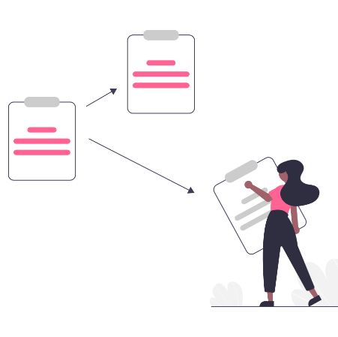
Why share records?
Sharing enables a clinician to get a full picture of all aspects that affect your/your child’s treatment. If some parts of your record are not available, this could impact your/your child’s treatment in a potentially negative way.


Who will your records be shared with?
Your information will only be shared with the health care teams involved with your care. Security measures are in place to ensure only those health care staff in the appropriate teams can access your medical records.

What will be shared?
Everything in your/your child’s medical history may be accessible to other HDFT services that have an open referral. Information received and written as part of the Occupational Therapy assessment will be included in your child’s electronic medical record. If you want to know more about this, please contact the service.

Your rights:
You have the right to restrict how and with whom we share personal information that identifies you. This must be noted explicitly within your records so that everyone involved in your care and treatment is aware of your decision.
Choosing this option may make the provision of treatment or care more difficult or unavailable. You can change your mind at any time about your decision.

